**SPRING DATA**

* **Create spring project**
* Visit <https://start.spring.io/>
* 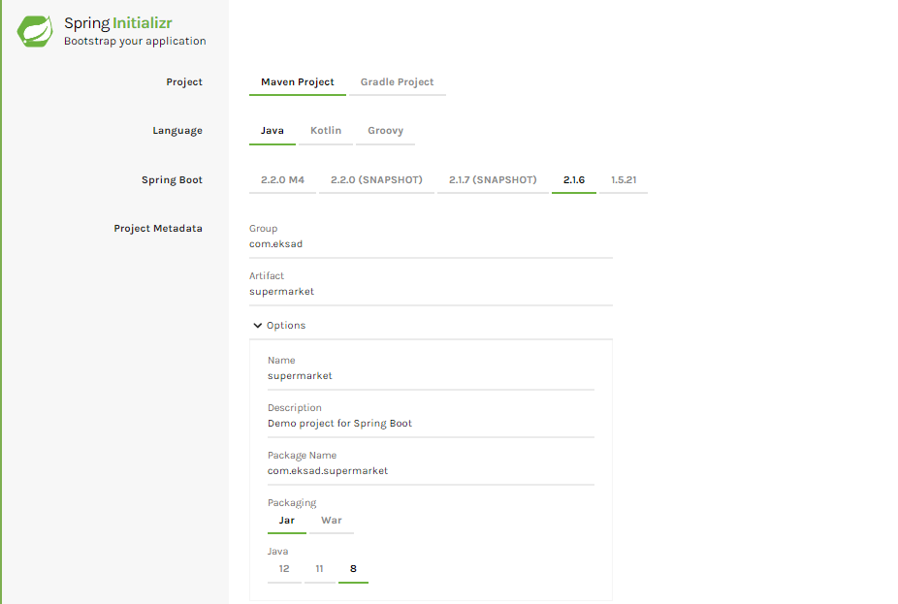
* 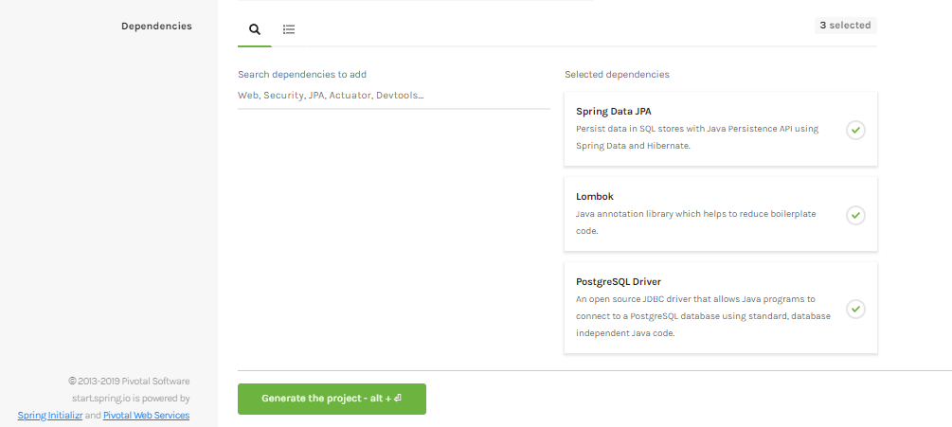
* **Create Entity**
* **Create new class**
* 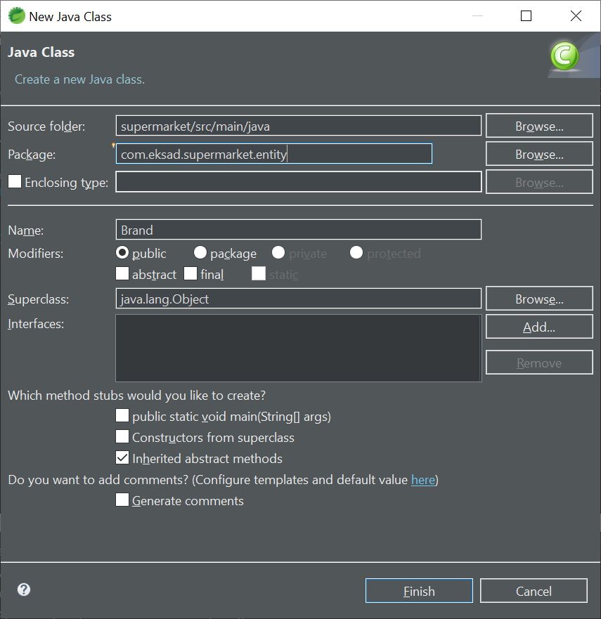
* 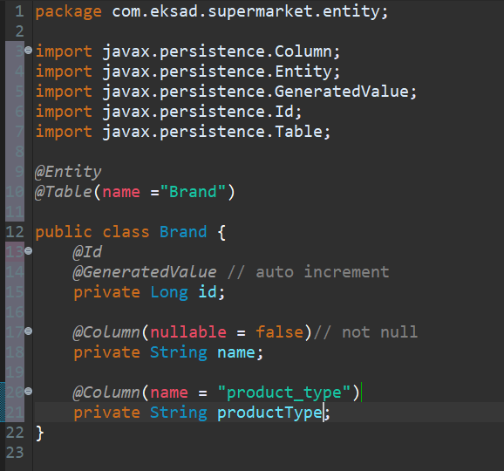
* **Install *Lombok***
* **Find *lombok.jar*** dalam mavendependency

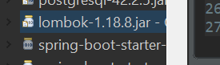

* **Go to path directory & install *lombok-1.18.8* set *“Specify location”***  **to *eclipse.exe***

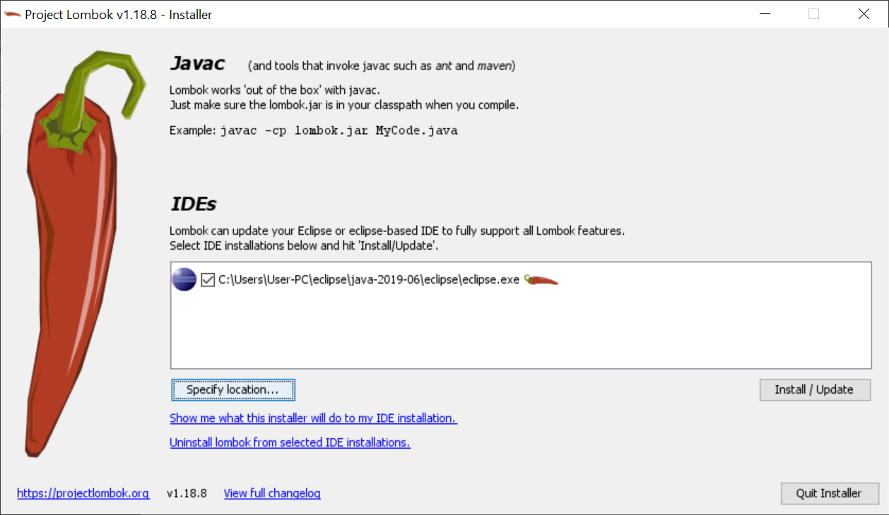

* **Add “*Lombok”* to project**



* **“*Lombok*” akan otomatis menambahkan *methode “Getter” “Setter”***
* **Atau**



* **Connect to database**
* **Buka file “*application.properyties*”\**

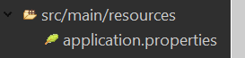

**Lalu isikan**



* 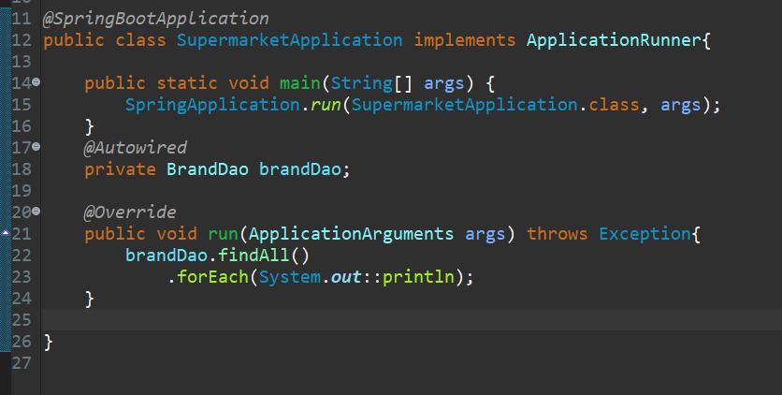

**Inheritance *@MappedSuperclass***

* 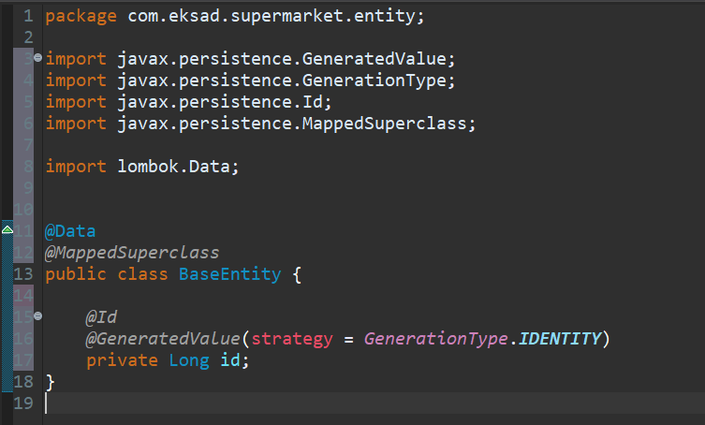
* 
* 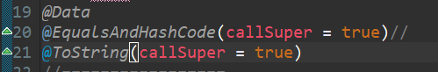

**Inheritance “*SingleTable”***

* 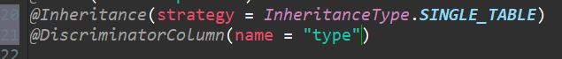
* ***Create new class (Chasier)***
* 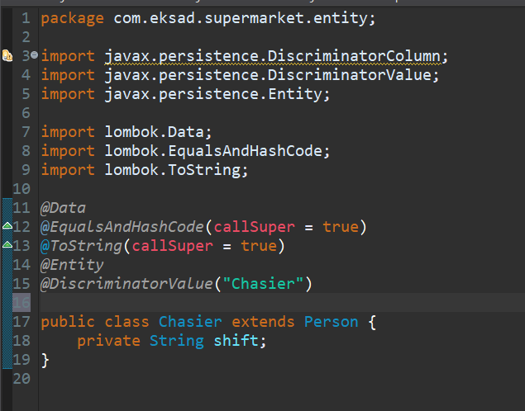
* ***Create new class (Customer)***
* 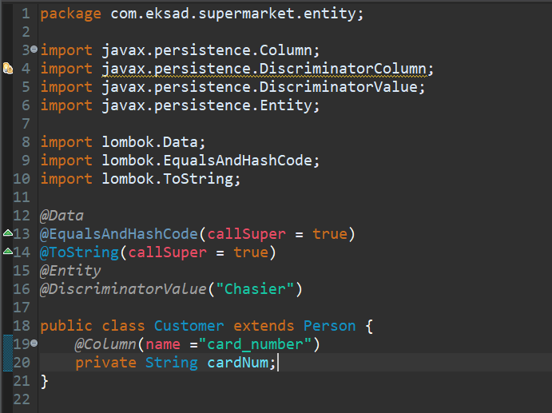
* ***Create DAO class***

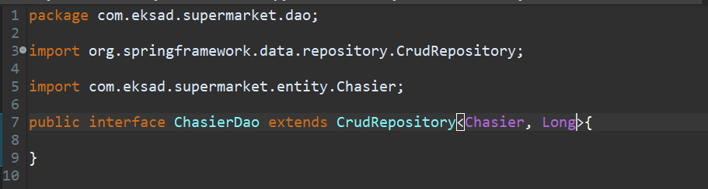

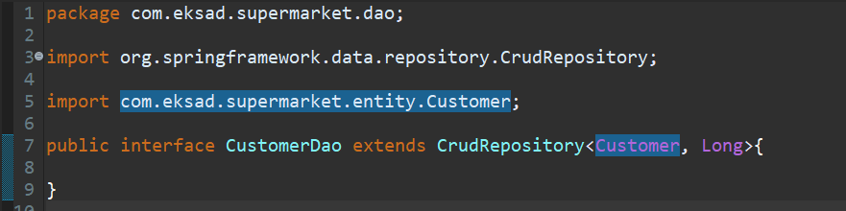

***JOIN TABLE***

* **Add annotation *inheritace* and *Discriminator* to superclass *“***public class Product { }

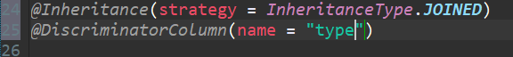

* ***Create new Class “***ProductGrocery***”***

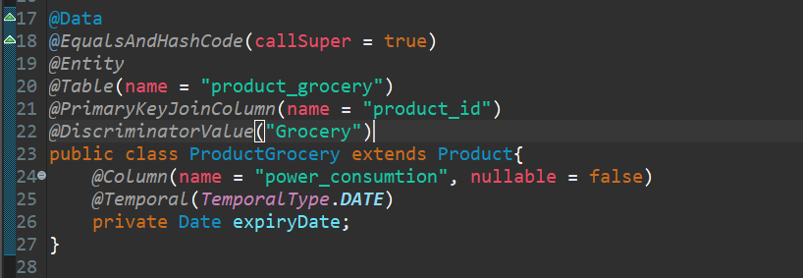

* ***Create new Class “***ProductElectronic***”***

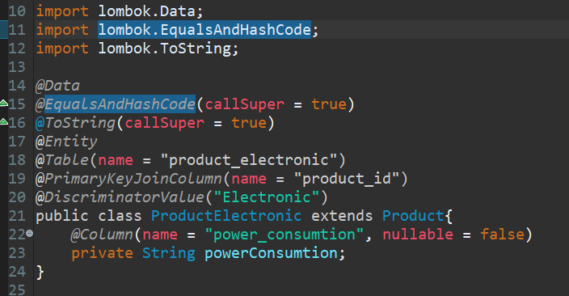

* ***Create Interface DAO “***ProductGroceryDao***”***

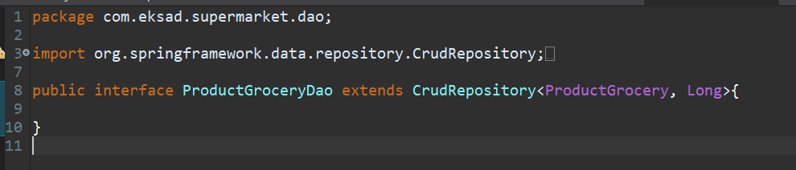

* ***Create interface DAO “***ProductElectronicDao***”***

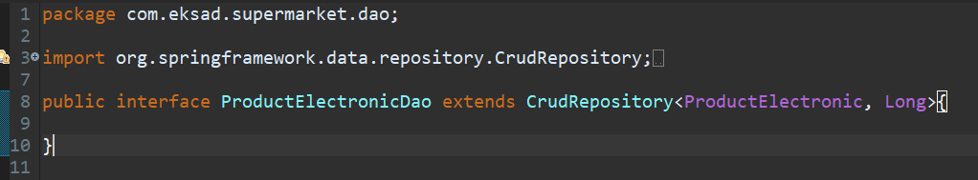

* ***Add Autowired***

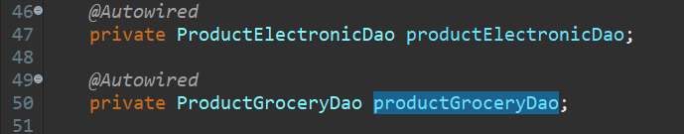

* ***Menampilkan Tabel***

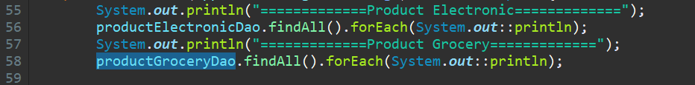

***QUERY USING DAO***

